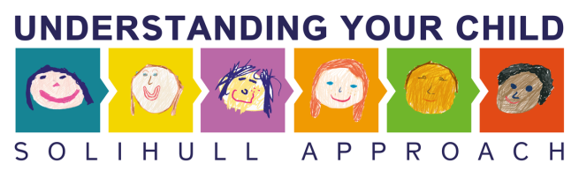
Leaflet for Parents
Is the Online Understanding Your Child Course for you?

What is it?
- This online course is based on the successful Understanding Your Child Parenting Group that is run across the country and here at First Steps. It is for parents and families of children aged 0 – 18.
- The course will give you practical ways of thinking about the stages of your child’s development and how you can strengthen and improve your relationships with your children.
Who is it for?
- Parents/ carers and family members who are confident with using computers and are interested in learning more about their relationship with their child, in particular:

  - Communication
  - Having fun together
  - Recognising and understanding different feelings
Get ideas for improving your relationship with your child

  - Development needs
  - Parenting styles
  - Behaviour difficulties
  - Sleep

How does it work?
- You will need 15 – 20 minutes to work through each module, which includes information, activities, a group of virtual parents and video clips. Make sure you are somewhere comfortable and that has internet connection and find a quiet space where you won’t be interrupted.
- You are asked to take a break of a few days in between completing each module. There are 12 modules in total, and we suggest that you take the course at a pace that suits you and your lifestyle!
- A member of our team will call you 3 – 4 weeks after you have received the course to see how you are finding it and to check if you have any questions.

To access the course, follow these steps:
- Anyone wishing to take the Parenting Online Course must first make a free account on Ourplace, by going to www.inourplace.co.uk and clicking on ‘Start now’, and you will be prompted to enter your name, email address, and create a password. This will be your account on Ourplace, and you can safely keep information here.

- Once you have made your account click on ‘Learn’ along the top of the screen, then in the box for ‘Parenting online course’ click on the ‘Take course’ or ‘Start now’ button.

- Click on the ’Already have a discount coupon?’ button. Enter the coupon code in the box and click ‘Apply coupon’, and once it is accepted then click on ‘Sign up’.

Then you can start your course! You can always access the course on www.inourplace.co.uk by going to ‘Learn’ along the top of the screen, and then clicking on ‘Take course’ in the ‘Parenting online course’ box. The course can be used on PCs, Macs, laptops, tablets and smartphones.

