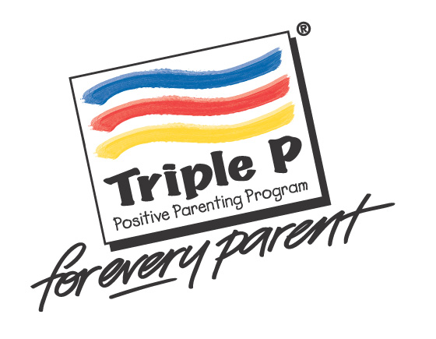



First Steps TRIPLE P PARENTING GROUP for Parents of teenagers

WHAT?

Do you have a child aged 12-16?

Adolescence brings lots of challenges, stresses, and
rewards – both for a teen and for their parents.

First Steps are going to be running a group for mums, dads and carers of teenagers, called the First Steps Triple P Parenting Group. Triple P (Positive Parenting Programme) aims to help parents understand the way their family works and suggests simple routines and small changes that can make a big difference. It has been helpful for many parents and may give some useful ideas to help you meet the challenges of raising your teenager.....

The group will cover a number of topics, including.....

Encouraging behaviours you like Developing positive relationships Teaching new skills and behaviours Dealing with teenagers’ emotions
Managing problem behaviour Dealing with risky behaviour
Taking care of yourself as a parent

We will do a range of activities in the group, including watching video clips, discussing experiences and concerns, sharing ideas, completing exercises, practising skills, home tasks, telephone support.

WHEN AND WHERE?

When: Fridays, 10am-12pm
Start: Friday 7th February – 3rd April 2020
(8 weeks programme)
Where: Young Hackney Youth Hub
29 Forest Road,
London,
E8 3BY



WHO IS RUNNING IT?

First Steps is an NHS Psychology Service, for children and young people aged 0-18 and their families. We aim to help with difficulties relating to behaviour, emotions and relationships. As well as running groups, we also offer individual support to families.



NEXT STEP....

If you are interested in attending the group, then you can self-refer or
ask a professional to refer you. Please call us on 0207 014 7135 to find
out more information and to see if this group is right for you. Places are
limited and will be allocated on a first-come first-served basis, so please
call soon. We will look forward to hearing from you!

“I wasn’t sure at first then after the first session I couldn’t believe how lucky I was to find such a support. This has helped me and my son so much. Thank you” (quote from a parent that completed the group)

