

**AFRICAN & CARIBBEAN PARENTING SPACE**

**February 13th**

**March 12th**

**April 16th**

**May 14th**

**June 18th**

**July 16th**

**August 13th**

**September 10th**

**October 15th**

**November 12th**

**December 10th**

First Steps met with Hackney parents of African and Caribbean children & young people to ask about the things they would like to know more about & how it should be delivered.

We will be having **interactive workshop sessions in the community** discussing different topics related to **parenting, culture and overall emotional-mental health & wellbeing**.

We aim to have discussions on topics that are important to **African and Caribbean heritage** **parents and parents of children with mixed heritage.** Sessions will be shaped collaboratively with families throughout the year.

**2020**

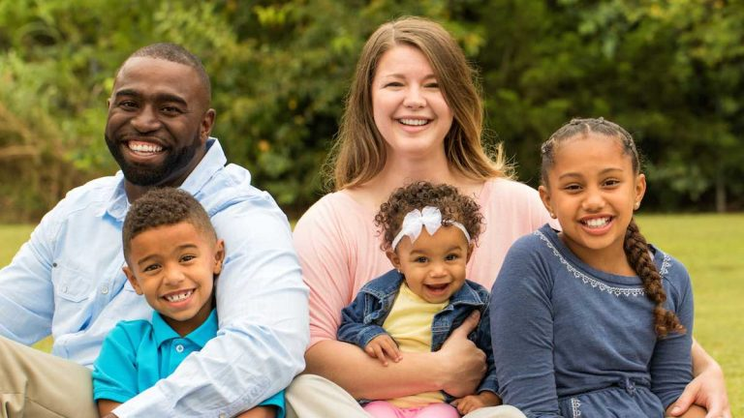

**If you are interested in attending or would like more information please call 020 7014 7135 or email** [**huh-tr.FirstSteps@nhs.net**](mailto:huh-tr.FirstSteps@nhs.net)

**Location & Topics will be decided and confirmed each month. Venues will be across Hackney to be accessible to all and topics will be decided collaboratively with parents during sessions and using feedback evaluations.**